<https://www.webdesignmuseum.org/gallery/youtube-2005>

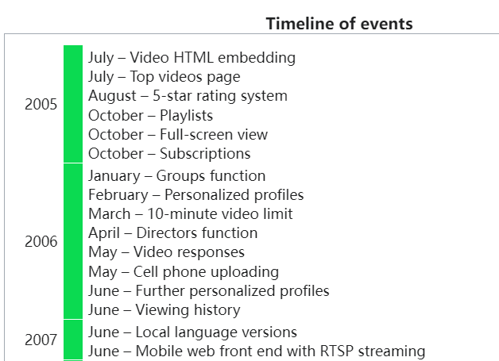

1. May 2005: YouTube’s Beta site was launched

YouTube first started out as a dating website, it had its user login above the video with a line where users can add their gender and what preference of partners they were looking for.

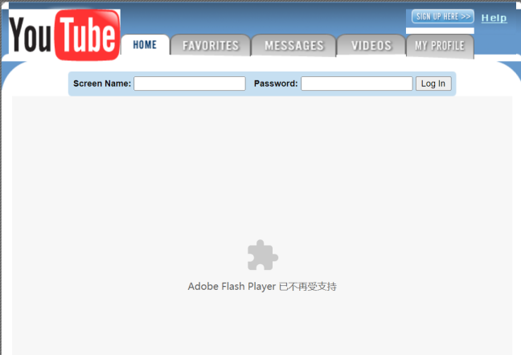

1. June 2005: The website was redesigned for the first time in June 2005. Where the website has changed to include a search bar. With the inclusion of a search bar it could now function as a video sharing website as people are now able to look for videos they want to watch. The most recent and popular keywords and videos were also displayed below it as well.

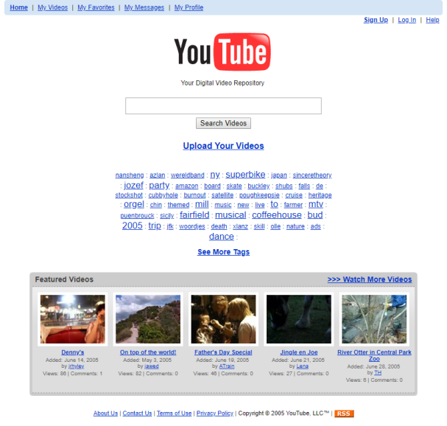

1. July 2005: Video HTML embedding was added to the site for the very first time. With more videos being uploaded they changed the layout again such that featured videos are now arranged in a list view as with a list view, creators are able to write a description of their videos which users are able to read about to get more information on the video. In addition, creators can remove comments left by others on their videos.

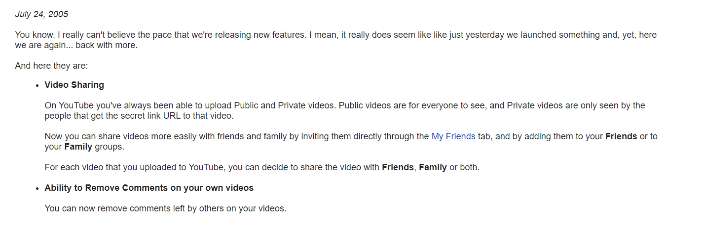

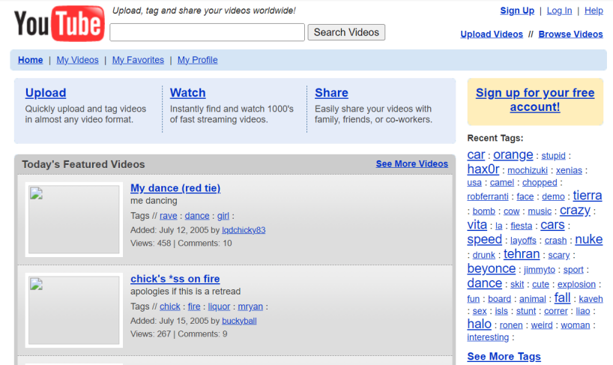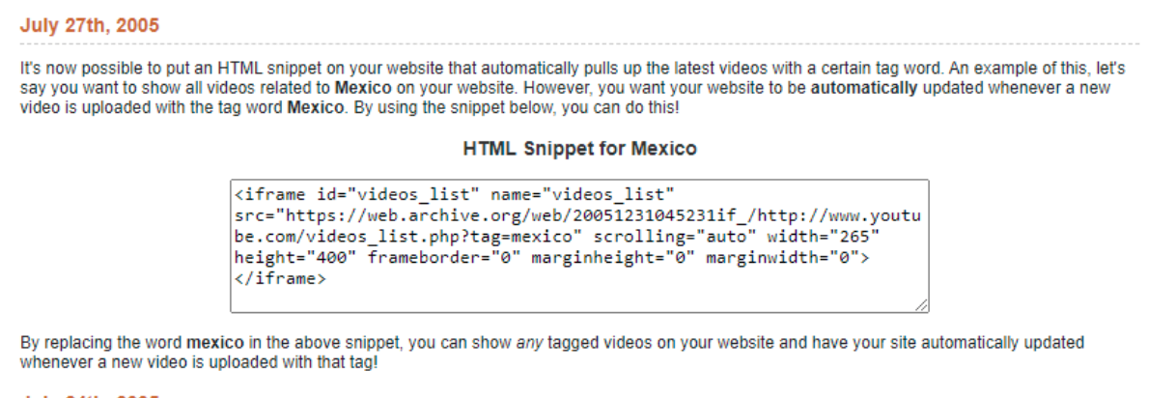

1. August 2005: 5-star rating system was added to YouTube.

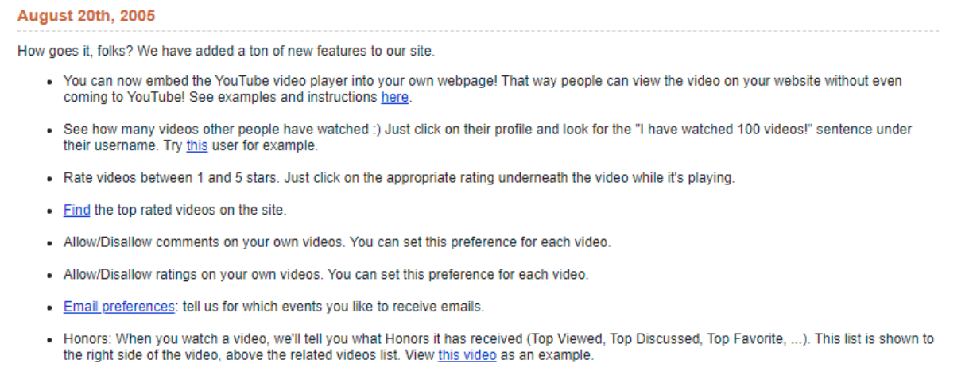

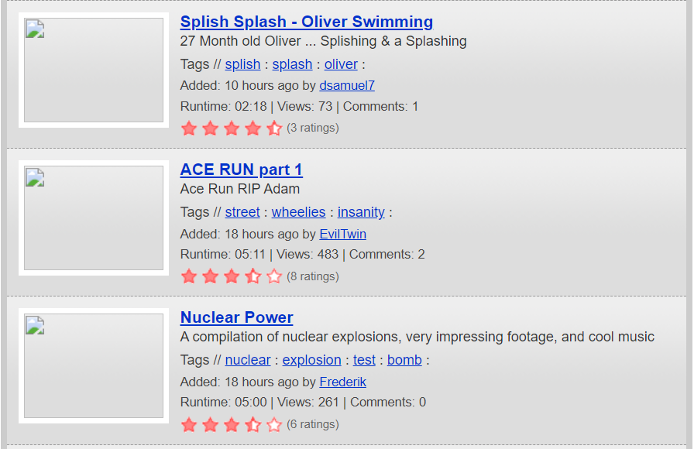

1. 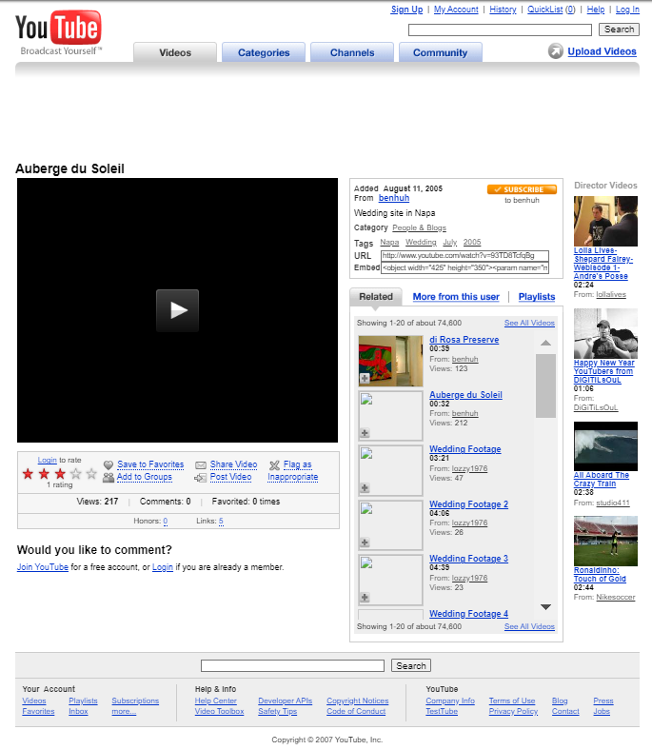October 2005: YouTube’s playlist function is added to YouTube for the first time. This would become an integral part of the platform for content creators and users. Full-screen video is also added to the site. YouTube also adds its subscription function. As of December 2005, the number of commentators’ videos, favorites, and friends was directly indicated in the comment section, as well as a video’s backlinks, comment counts in suggested videos, and rating indicator in video listings search results and channel pages. The site slogan was “Broadcast yourself. Watch and share your videos worldwide!”, which would later become just “Broadcast yourself”.

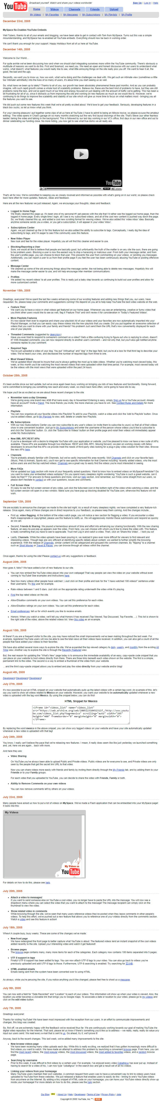

1. January 2006: YouTube adds its “Groups” feature to the platform.

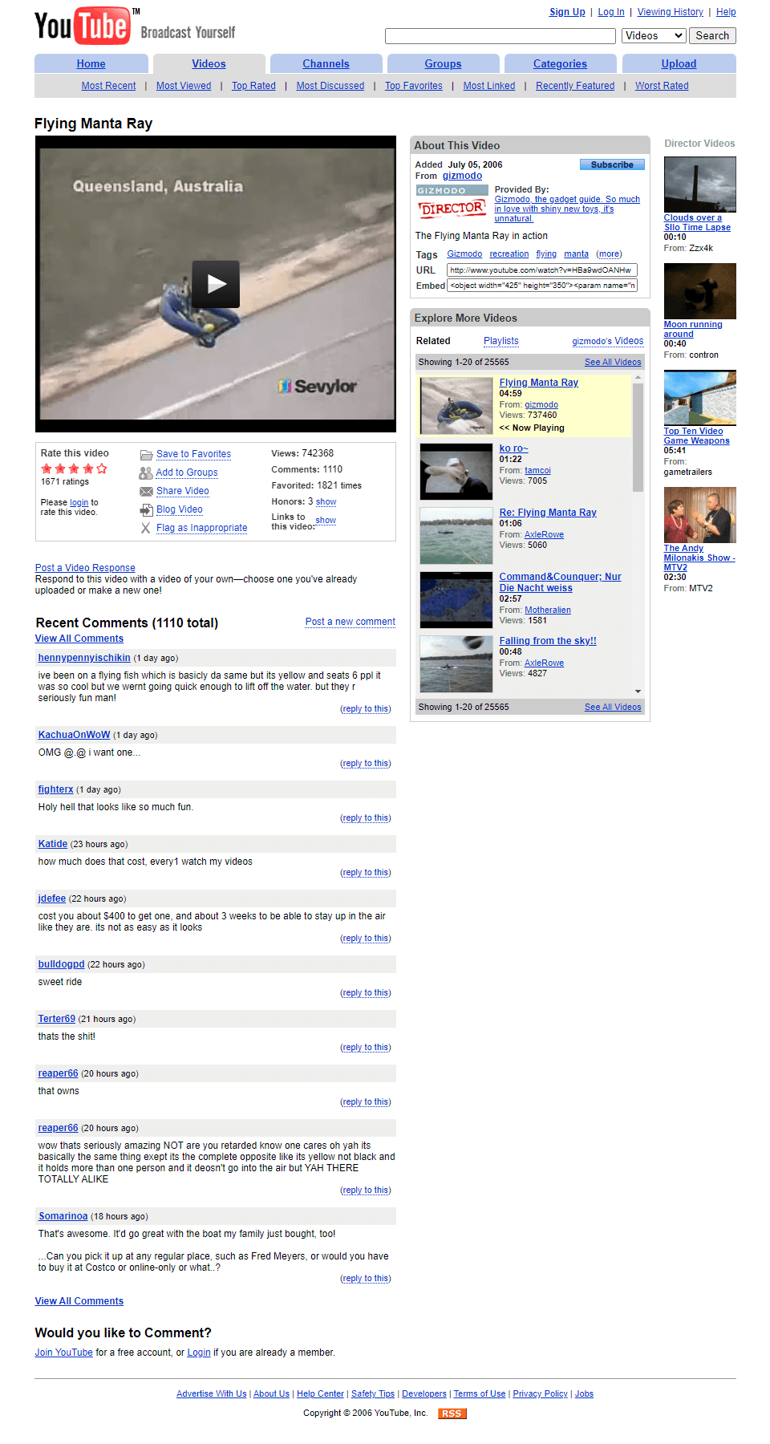

1. February 2006: For the first time, user profile personalization is added.

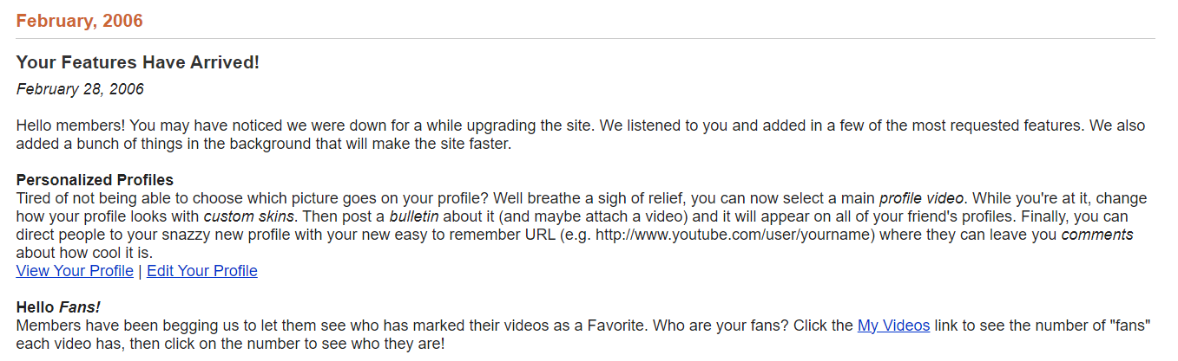

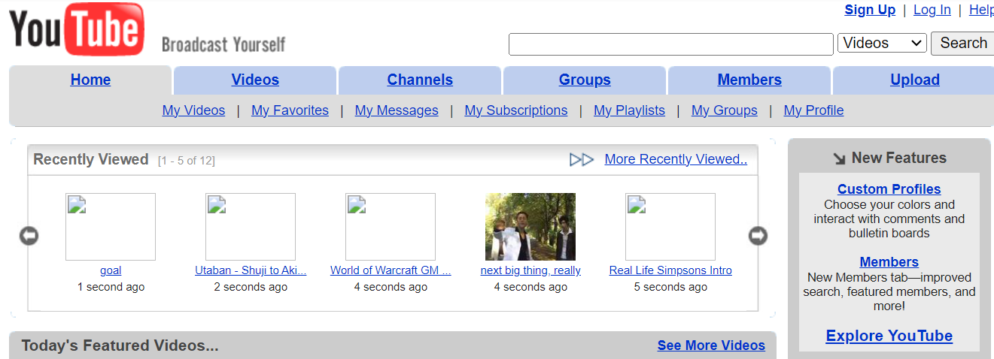

1. March 2006: YouTube adds a ten-minute limit to all uploaded video content.

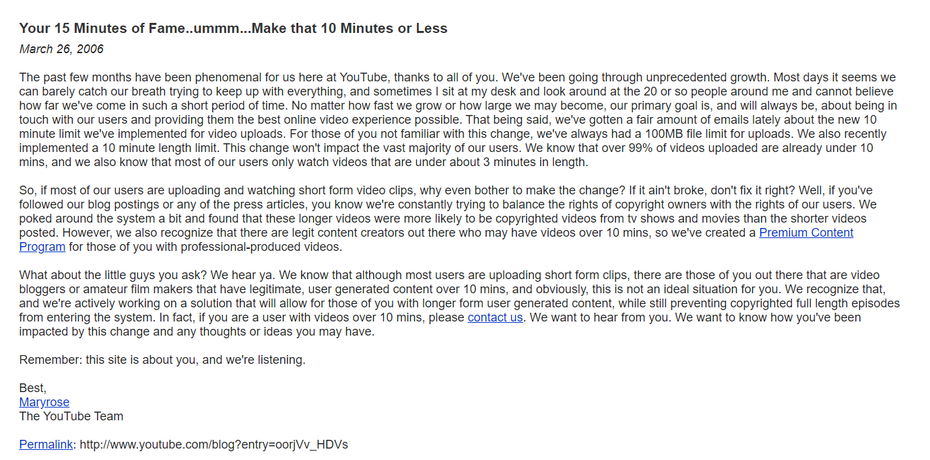

1. April 2006: YouTube adds its “Directors” function to the site.

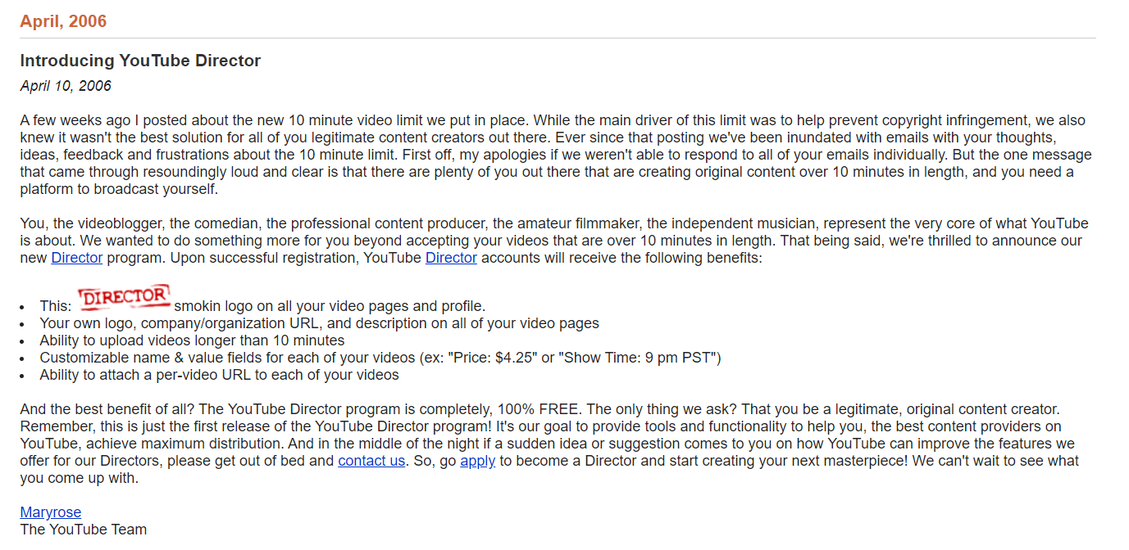

1. May 2006: Responses to videos are allowed for the first time. Cellphone video uploading functions are also included on the platform.

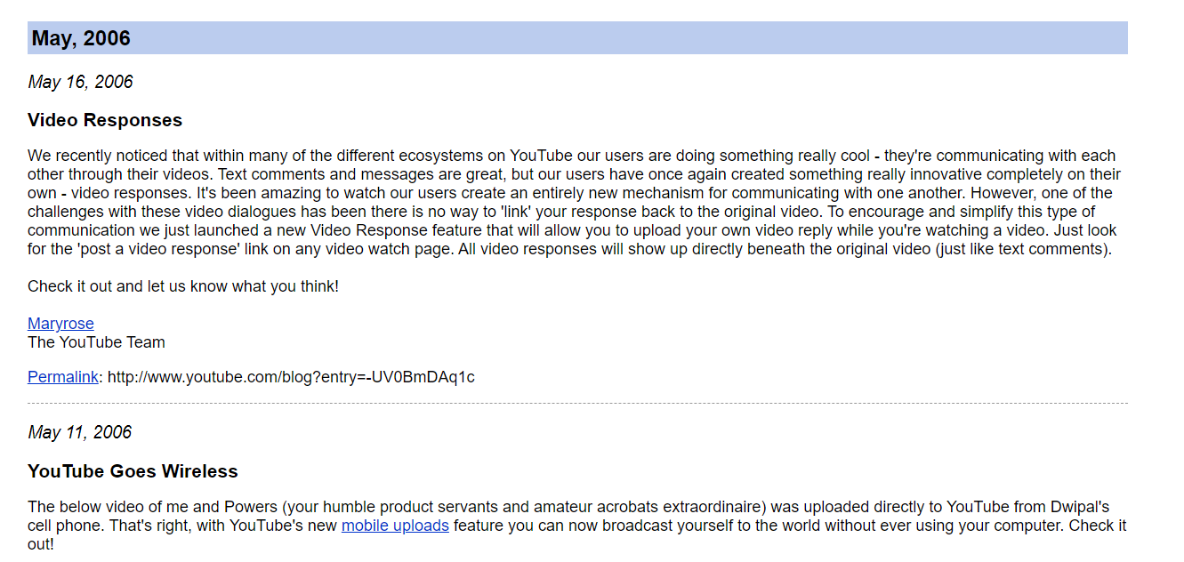

1. June 2006: Personalizing profile features is further refined, and user viewing history is added to the site.

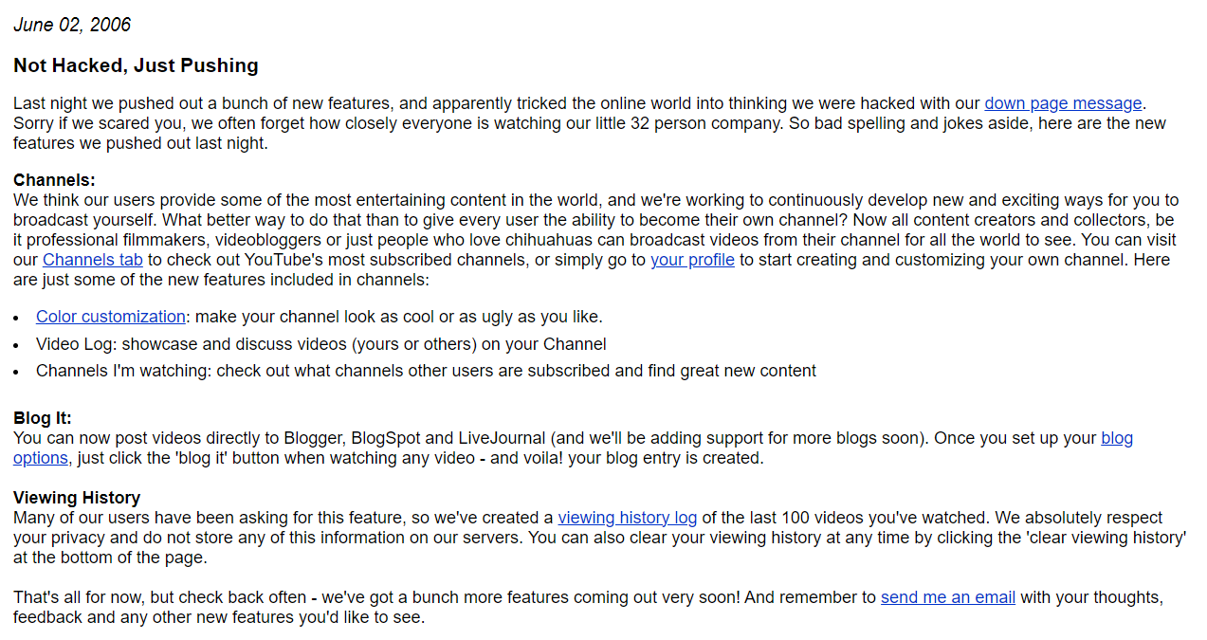

1. June 2007: YouTube allows other languages to be used on its site for the first time.

